Paper template for Euroregio BNAM 2022, Word version
Jonny Researcher^{1,*}, Jimmy Developer²
¹Department of Noise, Research Institute, Somecity, Somecountry.
²Research & Development, Industry Inc., Thatcity, Thatcountry.
*CorrespondingAuthor@email.org
Abstract
A maximum of 300 words should be used for the abstract, without including any equations, references or special characters. The abstract should give a clear description of the contents of the proposed work. The abstract should not continue on the second page.
Keywords: instructions, format, rules, recommendations, maximum of 5.e

Introduction
This document defines the template to be used in manuscript preparation for the Conference Euroregio BNAM 2022.

Submission and publication
All papers should be submitted using the conference website, https://bnam2022.org. Final papers will be published in the conference proceedings.

General format
The manuscript should be formatted according to this template, with the following specifications:

- The manuscript should be submitted in English.
- The manuscript should be submitted as a PDF file.
- The font size and type of the manuscript should be 11-point "Times New Roman".
- The page size shall be standard A4 (210 mm wide and 297 mm high).
- Margins shall be 2 cm on each side, while 3 cm on the top and the bottom of the page.
- The length of a manuscript should not exceed 10 pages, nor 10 MB.
- The manuscript will have to be re-submitted, if peer-review suggests changes.

Citing references
In the text, references should be cited using numbers between square brackets [1], in the order they appear in the text. Multiple references can also be made using a single pair of square brackets, as in the following citation [2,3].

Tables and Figures
Tables and figures should be cantered, numbered consecutively, and a caption should be always included. For tables the caption should be placed above, and for figures below. All figures and tables should be referred to from the text. See, for example, Table 1 that shows a simple table and Figure 1 that shows hearing threshold levels. Note that for long captions with more than one line the text should use the “Justify” alignment. If the caption is less that one line, then it should be centre aligned.

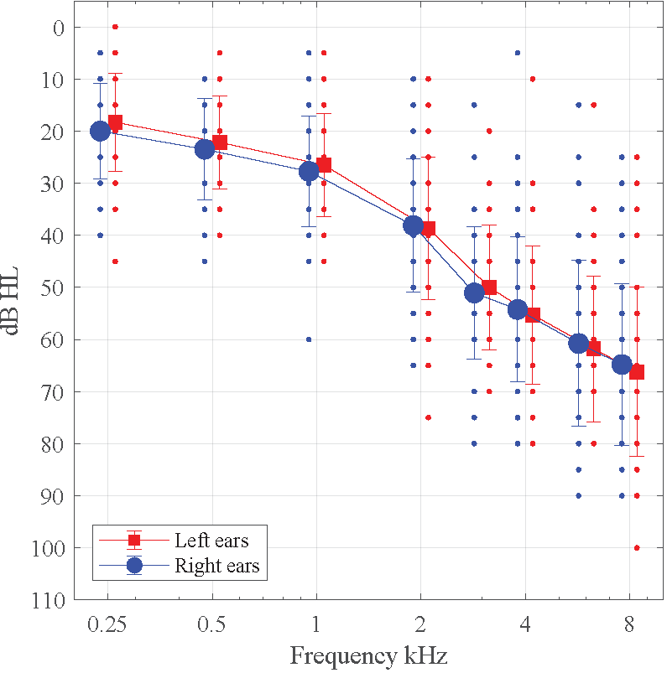
Figure 1: Pure tone thresholds. Caption rules are the same as for Tables.

Table 1: This is an example of a small table. Numbers are centred in the columns. The table caption has an extra margin of 30pt. on each side. If there is less that one line of caption then the text should be centred, if there are more than one line (as in this example), the caption should use “Justify” alignment.
A | B | C | D | E
3.5 | 7.0 | 10.5 | 14.0 | 17.5
7.0 | 10.5 | 14.0 | 17.5 | 3.5
10.5 | 14.0 | 17.5 | 3.5 | 7.0
14.0 | 17.5 | 3.5 | 7.0 | 10.5
17.5 | 3.5 | 7.0 | 10.5 | 14.0

Equations
Equations shall be centred and identified by a number, as the following:

$\underset{n→a}{Lim}\left[\frac{1}{{\left(x-a\right)}^{2}}\right]$ (1)

Refer to equations as to Equation (1) or simply (1). The use of the SI (System International) units is strongly recommended, and mixed units are to be avoided.

Conclusions
At least one of the authors should register in the conference and pay the registration fees. Otherwise, the paper will not be published in the conference proceedings.

Acknowledgements
Acknowledgements to persons or institutions should be placed in this section.

References
- Jenny Roe and Peter Aspinall. The restorative benefits of walking in urban and rural settings in adults with good and poor mental health. Health & place, 17(1):103–113, 2011.
- Thomas Munzel, Frank P. Schmidt, Sebastian Steven, Johannes Herzog, Andreas Daiber, and Mette Sørensen. Environmental noise and the cardiovascular system. J. Am. Coll. Cardiol., 71(6):688–697, 2018. doi: 10.1016/j.jacc.2017.12.015.
- Ajish K. Abraham and M. S. Ravishankar. A case study of acoustic intervention in classrooms. Building Acoustics, 28(4):293–308, 2021. doi: 10.1177/1351010X20975765.

